UNDERSTANDING AND MAINTANCE OF NETWORK

Assignment day-1

TASK 1: Draw a labeled diagram of a typical home Wi-Fi setup showing a modem, router, switch, access point, and at least two devices (like a laptop and smartphone) connected to the network.

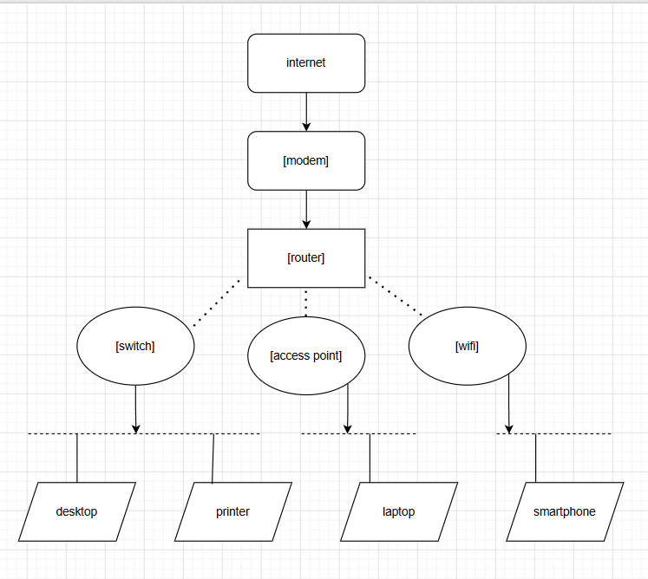
TASK2: List the main function of each networking hardware device: modem, router, switch, access point, and network cable. For each, give a real-life example of where you might see or use it (for example, 'router: at home to share internet')
Device | Main Function | Real-Life Example
Modem | Connects your home network to the Internet. | At home, connected to the ISP (Jio, Airtel, BSNL).
Router | Shares the Internet with multiple devices and manages network traffic. | Home Wi-Fi router.
Switch | Connects multiple wired devices in a Local Area Network (LAN). | Used in offices or computer labs.
Access Point (AP) | Extends or provides wireless (Wi-Fi) connectivity. | In schools, malls, hotels, or large offices.
Network Cable (Ethernet) | Transfers data between network devices through a wired connection. | Connecting a computer to a router or switch.

TASK3: Take photos or find images online (with source links) of at least three types of network cables (such as Ethernet, coaxial, fiber optic) and write one line describing where each is commonly used.
Cable Type | Common Use | Source
Ethernet (RJ45) | Used to connect computers, routers, and switches in homes and offices. | https://en.wikipedia.org/wiki/Ethernet_over_twisted_pair
Coaxial Cable | Used for cable TV and broadband Internet connections. | https://en.wikipedia.org/wiki/Coaxial_cable
Fiber Optic Cable | Used for high-speed Internet and long-distance communication. | https://en.wikipedia.org/wiki/Optical_fiber

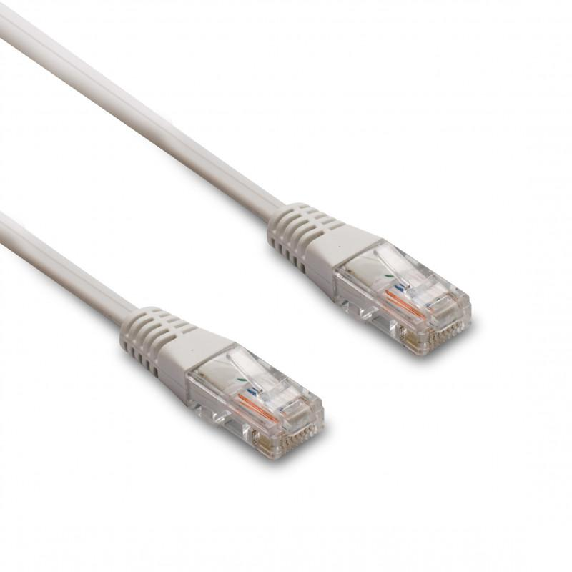
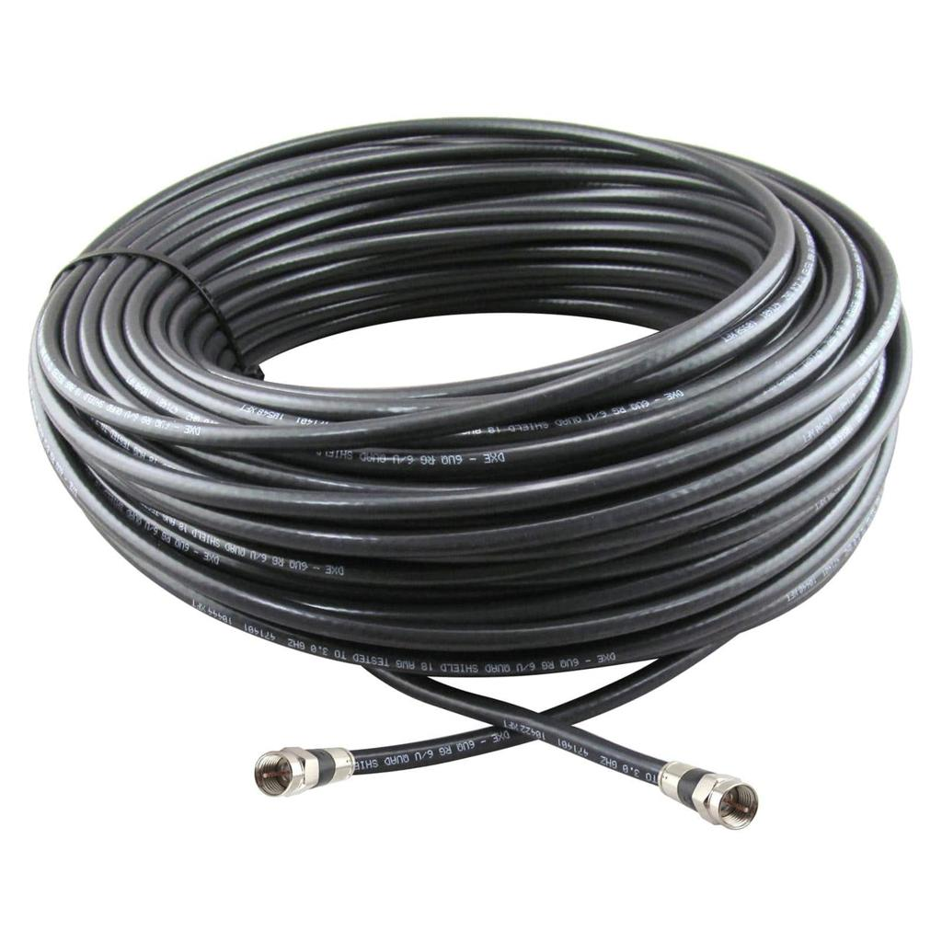
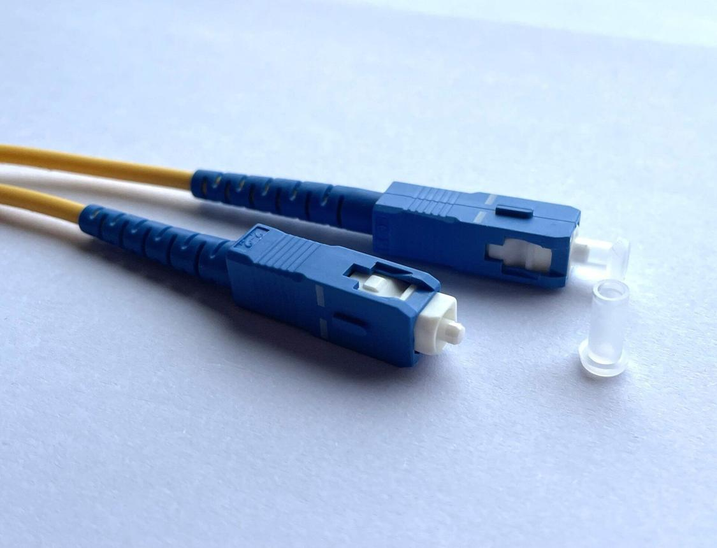
TASK4: Create a comparison table listing at least four differences between a router and a switch, including their main use, typical location, and how they handle data.
Feature | Router | Switch
Main Use | Connects different networks and shares the Internet. | Connects devices within the same network.
Typical Location | Homes, offices, schools. | Offices, computer labs, data centers.
How It Handles Data | Uses IP addresses to send data between networks. | Uses MAC addresses to send data within a LAN.
Internet Connection | Connects directly to the modem and Internet. | Does not connect directly to the Internet.
Wireless Support | Usually provides Wi-Fi. | Usually provides only wired connections.

